Assignment 3: Perform Parsing of Family Tree Using Knowledge Base

Problem Statement
The goal of this assignment is to parse a family tree using a knowledge base and infer relationships such as parent, sibling, or cousin. By applying logical reasoning, you will deduce various familial connections.

Objectives
- Understand knowledge representation and reasoning in artificial intelligence.
- Use inference rules to parse and deduce relationships within a family tree.

Theory

Knowledge Representation
Knowledge representation is a crucial aspect of artificial intelligence that involves defining entities (such as family members) and their relationships in a format that a computer can utilize to perform reasoning.

Inference
Inference is the process of deriving new information or relationships from existing facts using defined rules. In the context of a family tree, this involves applying logical rules to determine familial relationships.

Methodology
- Represent Family Members and Relationships:
  - Use facts to represent family members and their direct relationships. For example, you might define facts like:
    - parent(John, Mary). (John is a parent of Mary)
    - parent(John, David). (John is a parent of David)
    - parent(Mary, Sara). (Mary is a parent of Sara)
- Define Rules for Inferring Relationships:
  - Establish rules that define how to infer new relationships from existing ones. For instance:
    - sibling(X, Y) :- parent(Z, X), parent(Z, Y), X \= Y. (X and Y are siblings if they share at least one parent and are not the same person)
    - cousin(X, Y) :- parent(A, X), parent(B, Y), sibling(A, B). (X and Y are cousins if their parents are siblings)
- Apply Rules to Infer New Relationships:
  - Implement a reasoning engine that applies the defined rules to the facts in the knowledge base. This can be done using logic programming languages like Prolog or through custom implementations in Python.

Working Principle / Algorithm
Here’s a simple outline of the steps to parse the family tree:
- Input the Family Data:
  - Populate the knowledge base with facts representing family members and their direct relationships.
- Define Inference Rules:
  - Write rules that enable inference of new relationships (e.g., sibling, cousin).
- Query the Knowledge Base:
  - Use queries to extract information about relationships. For example, asking for all siblings of a particular individual or identifying all cousins.
- Output Inferred Relationships:
  - Display the relationships that have been inferred from the knowledge base.

Advantages
- Complex Reasoning: This method allows for advanced reasoning capabilities and the ability to deduce intricate relationships that may not be immediately obvious.
- Flexibility: The knowledge base can be easily modified or expanded to include more facts or rules.

Disadvantages / Limitations
- Complexity: As the family tree grows in size and complexity, managing and querying the knowledge base may become increasingly difficult.
- Performance: Inference over a large set of rules and facts can lead to performance issues, especially if the rules are not optimized.

Diagram

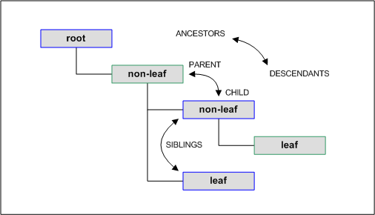

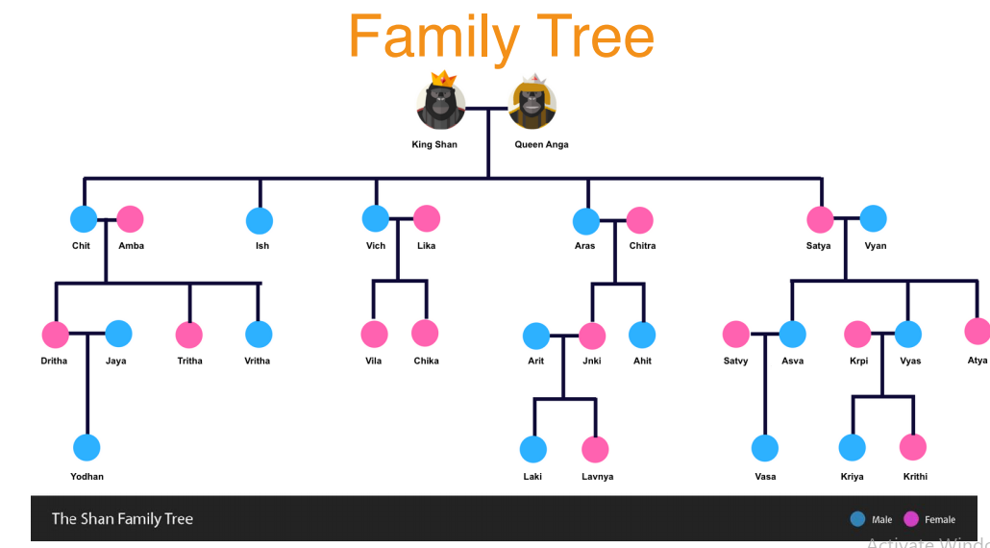

Conclusion
Using a knowledge base combined with inference rules provides a structured and effective way to parse and deduce relationships within a family tree. This approach enhances our ability to reason about familial connections, enabling a clearer understanding of the family structure.

Code :-
import java.util.*;

public class FamilyTreeParser {

// Knowledge Base
static Map<String, List<String>> father = new HashMap<>();
static Map<String, List<String>> mother = new HashMap<>();

// --- Add Facts ---
static void addFather(String f, String c) {
father.computeIfAbsent(f, k -> new ArrayList<>()).add(c);
}

static void addMother(String m, String c) {
mother.computeIfAbsent(m, k -> new ArrayList<>()).add(c);
}

// --- Rules ---
// Parent Rule: returns list of children
static List<String> getChildren(String p) {
List<String> result = new ArrayList<>();
if (father.containsKey(p)) result.addAll(father.get(p));
if (mother.containsKey(p)) result.addAll(mother.get(p));
return result;
}

// Sibling Rule
static List<String> getSiblings(String name) {
List<String> result = new ArrayList<>();

// check in father map
for (Map.Entry<String, List<String>> entry : father.entrySet()) {
List<String> children = entry.getValue();
if (children.contains(name)) {
for (String c : children) {
if (!c.equals(name) && !result.contains(c))
result.add(c);
}
}
}

// check in mother map
for (Map.Entry<String, List<String>> entry : mother.entrySet()) {
List<String> children = entry.getValue();
if (children.contains(name)) {
for (String c : children) {
if (!c.equals(name) && !result.contains(c))
result.add(c);
}
}
}

return result;
}

// Grandparent Rule
static List<String> getGrandchildren(String gp) {
List<String> result = new ArrayList<>();

if (father.containsKey(gp)) {
for (String child : father.get(gp)) {
result.addAll(getChildren(child));
}
}
if (mother.containsKey(gp)) {
for (String child : mother.get(gp)) {
result.addAll(getChildren(child));
}
}

return result;
}

// --- Main ---
public static void main(String[] args) {
Scanner sc = new Scanner(System.in);

// --- FACTS ---
addFather("Mohan", "Ram");
addFather("Mohan", "Shyam");
addFather("Mohan", "Gita");
addMother("Sita", "Ram");
addMother("Sita", "Shyam");
addMother("Sita", "Gita");
addFather("Shyam", "Anu");
addFather("Shyam", "Raju");

System.out.println("Family Tree Knowledge Base Parser");
System.out.println("----------------------------------");
System.out.println("Queries Supported:");
System.out.println("1. children <name>");
System.out.println("2. siblings <name>");
System.out.println("3. grandchildren <name>");
System.out.println("Type 'exit' to quit.\n");

while (true) {
System.out.print("Enter query: ");
String query = sc.next();
if (query.equalsIgnoreCase("exit"))
break;
String name = sc.next();

if (query.equalsIgnoreCase("children")) {
List<String> res = getChildren(name);
if (res.isEmpty())
System.out.println(name + " has no children.");
else
System.out.println("Children of " + name + ": " + String.join(" ", res));
}
else if (query.equalsIgnoreCase("siblings")) {
List<String> res = getSiblings(name);
if (res.isEmpty())
System.out.println(name + " has no siblings.");
else
System.out.println("Siblings of " + name + ": " + String.join(" ", res));
}
else if (query.equalsIgnoreCase("grandchildren")) {
List<String> res = getGrandchildren(name);
if (res.isEmpty())
System.out.println(name + " has no grandchildren.");
else
System.out.println("Grandchildren of " + name + ": " + String.join(" ", res));
}
else {
System.out.println("Unknown query type!");
}
}
sc.close();
}
}
Output :-
Family Tree Knowledge Base Parser
----------------------------------
Queries Supported:
1. children <name>
2. siblings <name>
3. grandchildren <name>
Type 'exit' to quit.

Enter query: children Mohan
Children of Mohan: Ram Shyam Gita

Enter query: children Sita
Children of Sita: Ram Shyam Gita

Enter query: siblings Ram
Siblings of Ram: Shyam Gita

Enter query: siblings Gita
Siblings of Gita: Ram Shyam

Enter query: children Shyam
Children of Shyam: Anu Raju

Enter query: grandchildren Mohan
Grandchildren of Mohan: Anu Raju

Enter query: grandchildren Sita
Grandchildren of Sita: Anu Raju

Enter query: grandchildren Ram
Ram has no grandchildren.

Enter query: exit

